Assignment No 2

Muahmmad Sami Rizwan  
Jawan Pakistan   
Section B

**(1)What are the various types of operators in dart? Explain with Examples.**

The operators are special symbols that are used to carry out certain operations on the operands. The Dart has numerous built-in operators which can be used to carry out different functions, for example, ‘+’ is used to add two operands. Operators are meant to carry operations on one or two operands.

**Different types of operators in Dart:**

The following are the various types of operators in Dart:

1) Arithmetic Operators  
2) Equality and Relational Operators  
3) Logical Operators

**ARITHMETIC OPERATORS:**

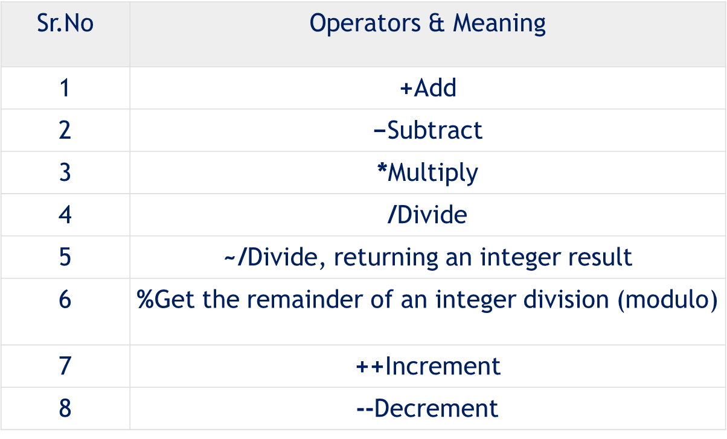

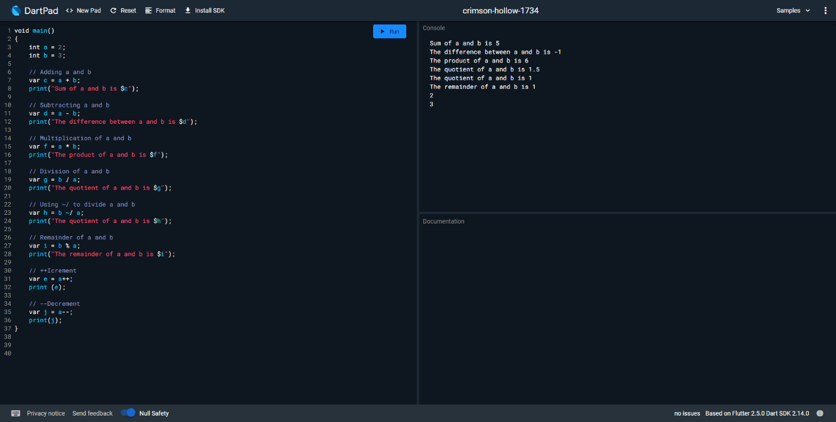

**EQUALITY & RELATIONAL OPERATORS:**

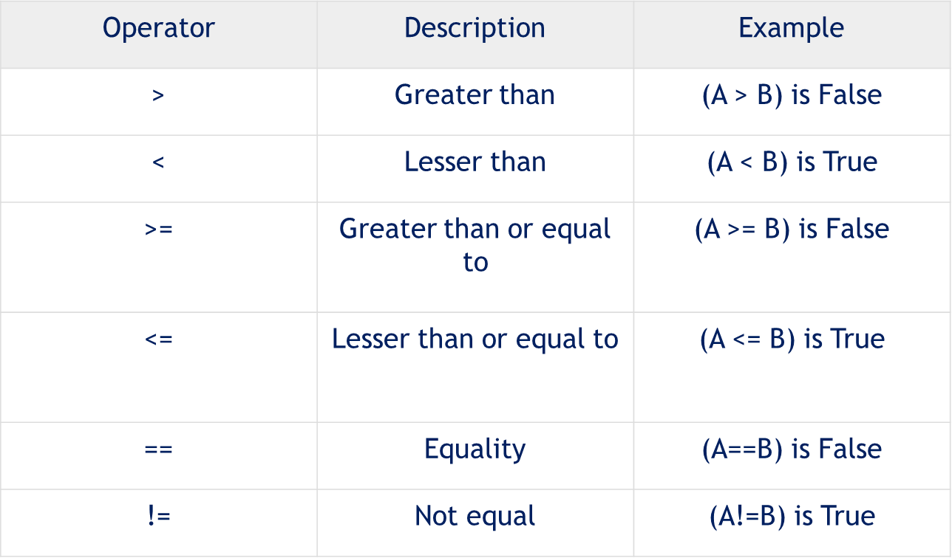

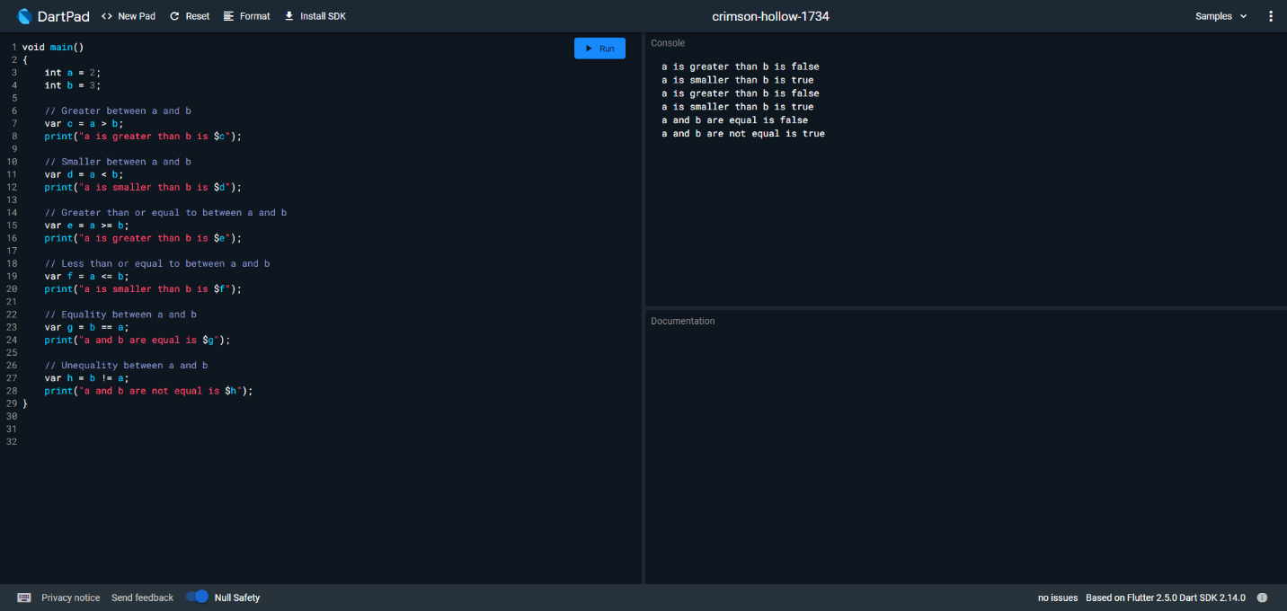

**LOGICAL OPERATORS:**

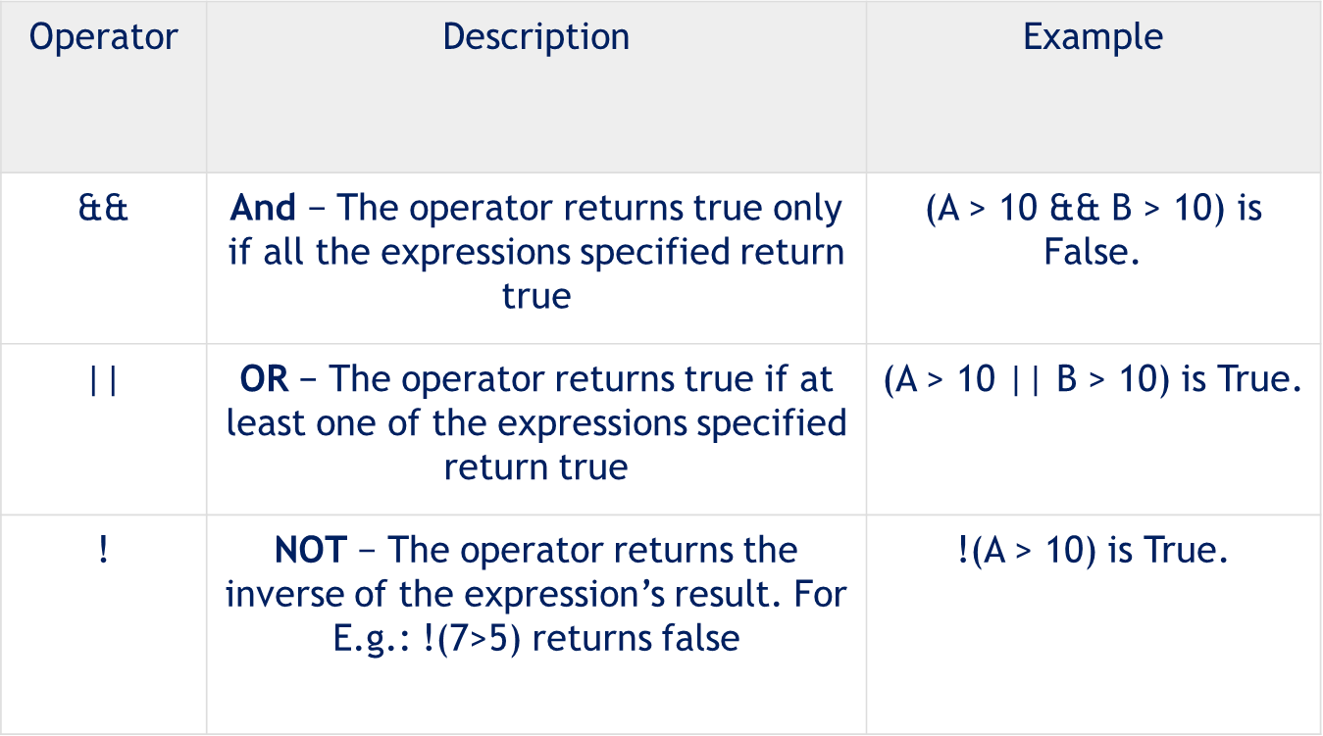

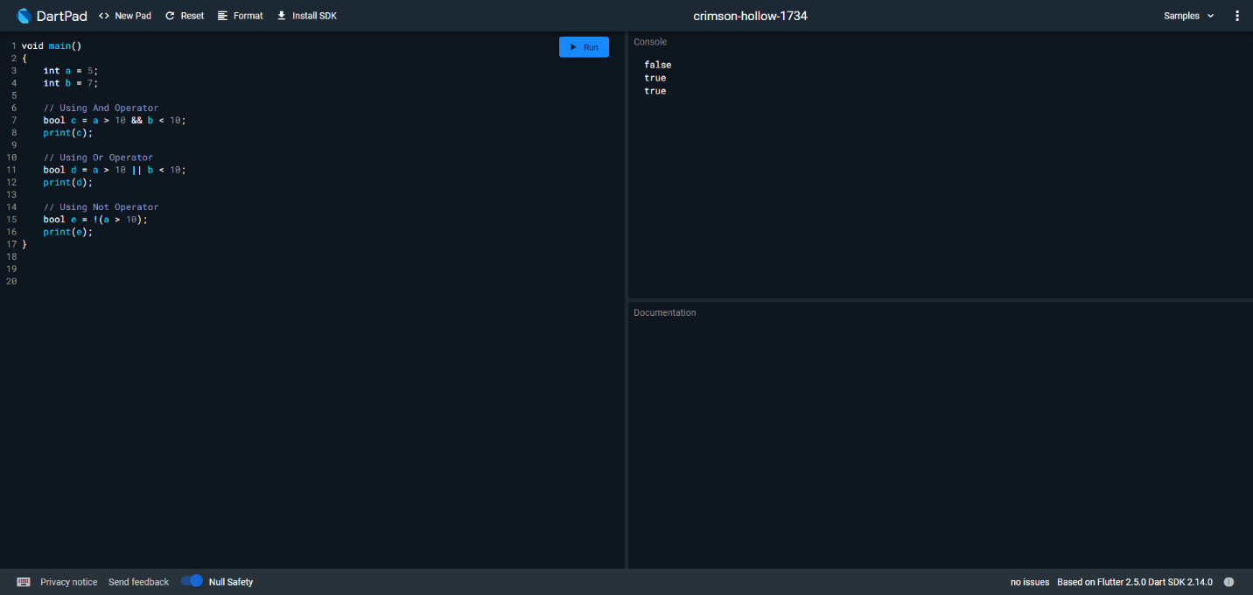

**(2)What will be the output in variables a, b & result after execution of the**

**following script:**

**a. var a = 2, b = 1;**

**b. var result = --a - --b + ++b + b--;**

**Explain the output at each stage:**

**c. --a;**

**The answer is 1**

**d. --a - --b;**

**The answer is 1**

**e. --a - --b + ++b;**

**The answer is 2**

**f. --a - --b + ++b + b--;**

**The answer is 3**

**(3)Cost of one movie ticket is 600 PKR. Write a script to store ticket price in a**

**variable & calculate the cost of buying 5 tickets to a movie.**

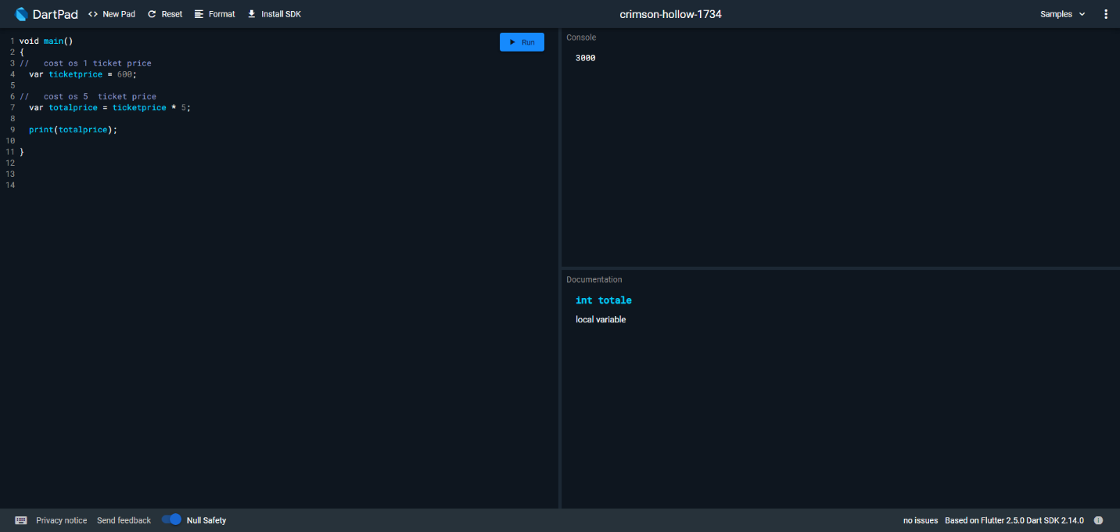

**(4) How to get difference of lists in Dart?**

**Problem: Consider you have two lists [1,2,3,4,5,6,7] and [3,5,6,7,9,10]. How**

**would you get the difference as output? E.g. [1, 2, 4].**

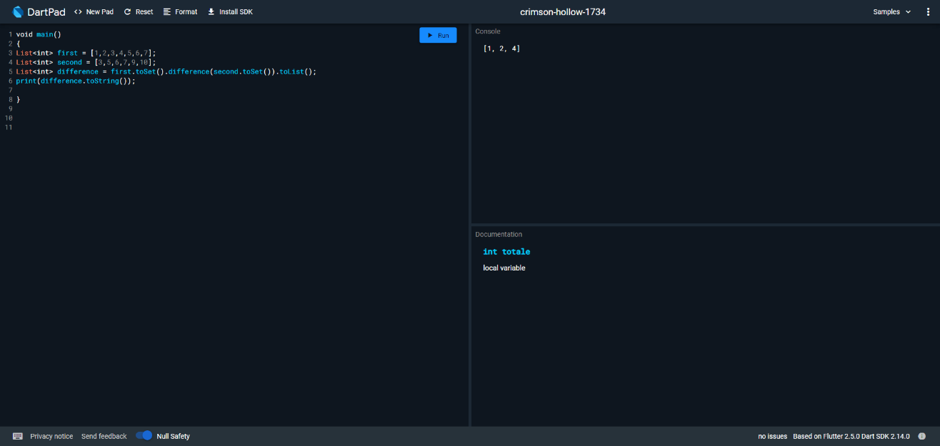

**(5)What is a difference between these operators “?? And?”**

### **Conditional expressions**

Dart has two operators that let you concisely evaluate expressions that might otherwise require if-else statements:

**condition*?*expr1*:*expr2**

If condition is true, evaluates expr1 (and returns its value); otherwise, evaluates and returns the value of expr2.

**expr1*??*expr2**

If expr1 is non-null, returns its value; otherwise, evaluates and returns the value of expr2.

**(6)What are the data types supported in Dart? Explain with Examples.**

**List of All data types in DART:**

1. Numbers – int, double
2. String
3. Boolean
4. List
5. Map
6. **Numbers:**

Numbers in Dart are used to represent numeric literals.

**Keyword: int, num, double**

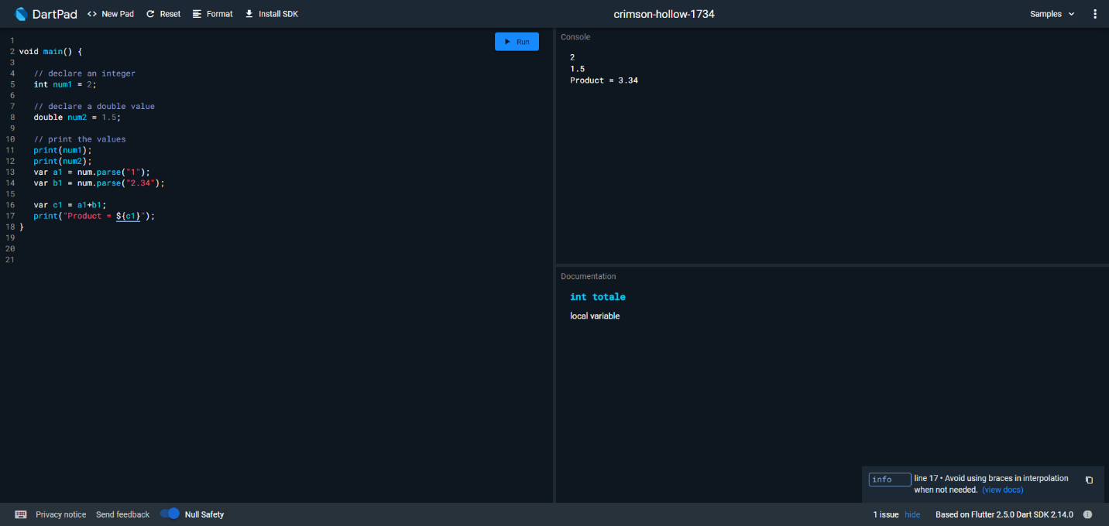

1. **String:**

 It used to represent a sequence of characters. It is a sequence of UTF-16 code units. The keyword string is used to represent string literals. String values are embedded in either single or double-quotes.

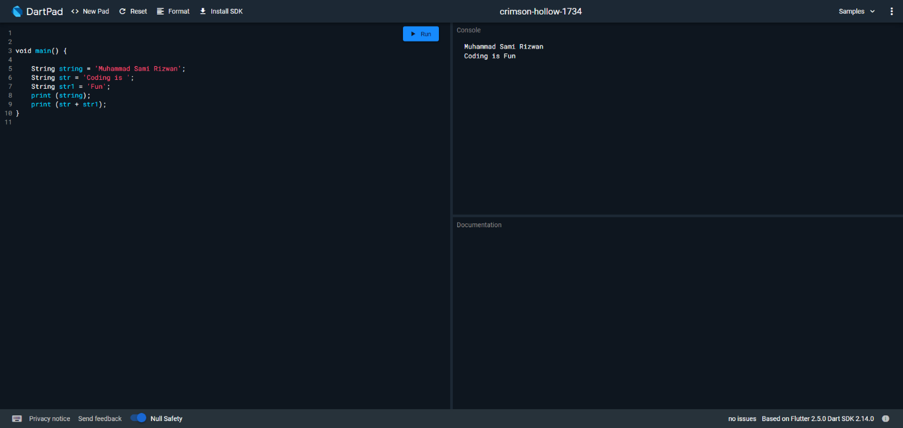

**3.Boolean:**

It represents Boolean values true and false. The keyword bool is used to represent a Boolean literal in DART.

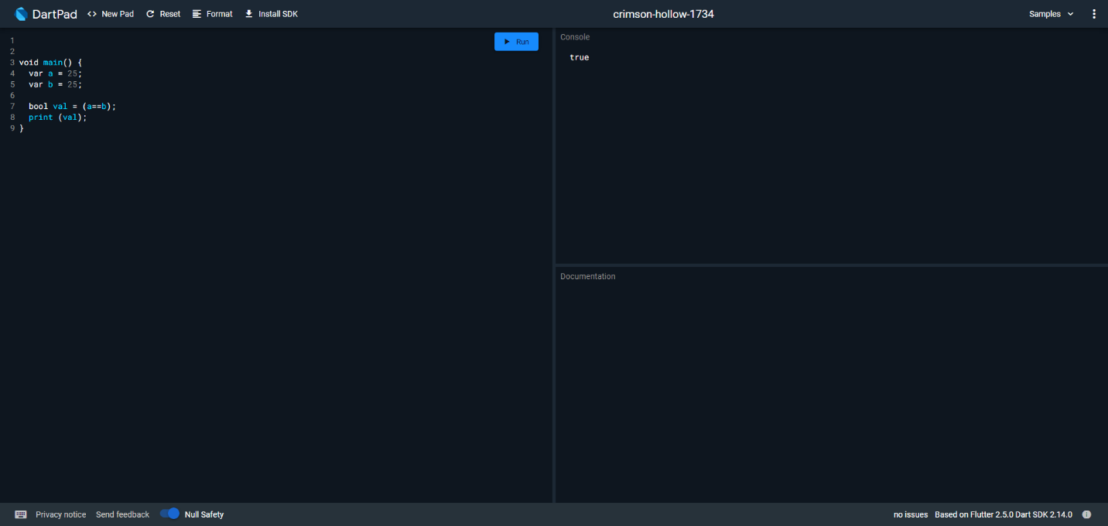

**4.List:**

List data type is similar to arrays in other programming languages. A list is used to represent a collection of objects. It is an ordered group of objects.

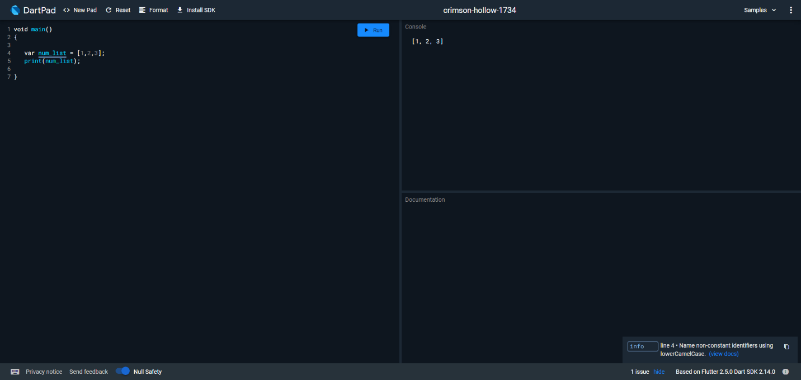

**6. Map:**

The Map object is a key and value pair. Keys and values on a map may be of any type. It is a dynamic collection.

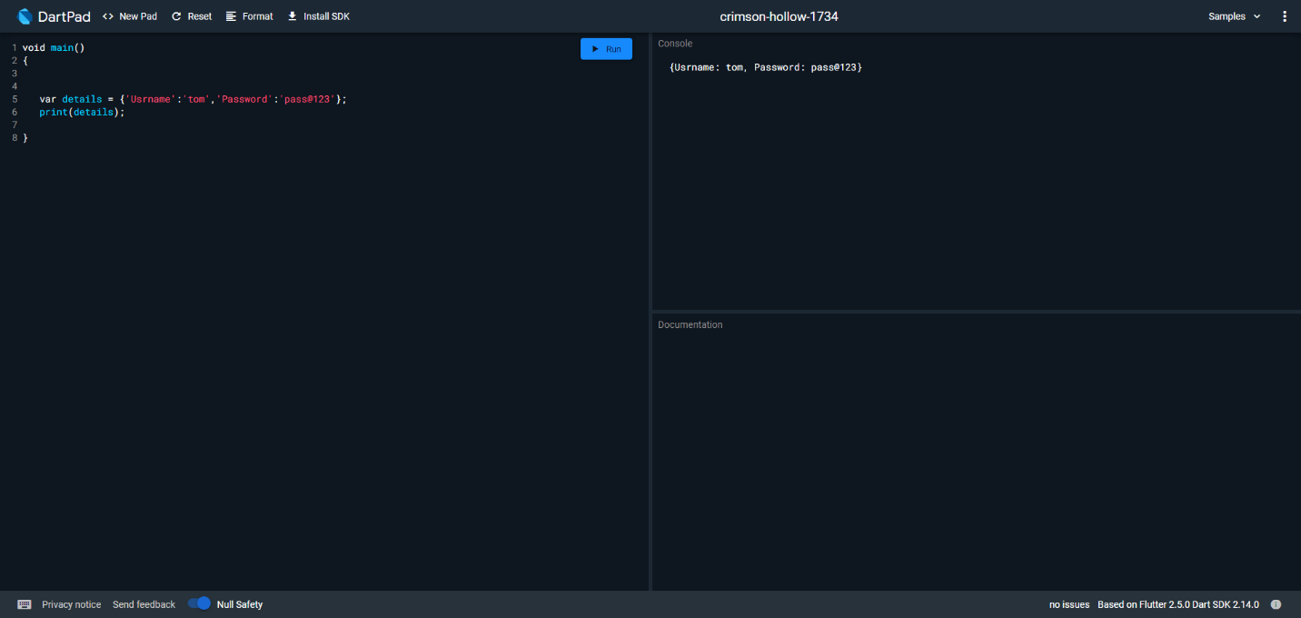

**(7)Solve:**

**a. First declare an array and assign the numbers of the table of 7.**

**b. Second declare another array and assign the numbers 1-10**

**c. Now write down the table of 7 using map.fromiterables method.**

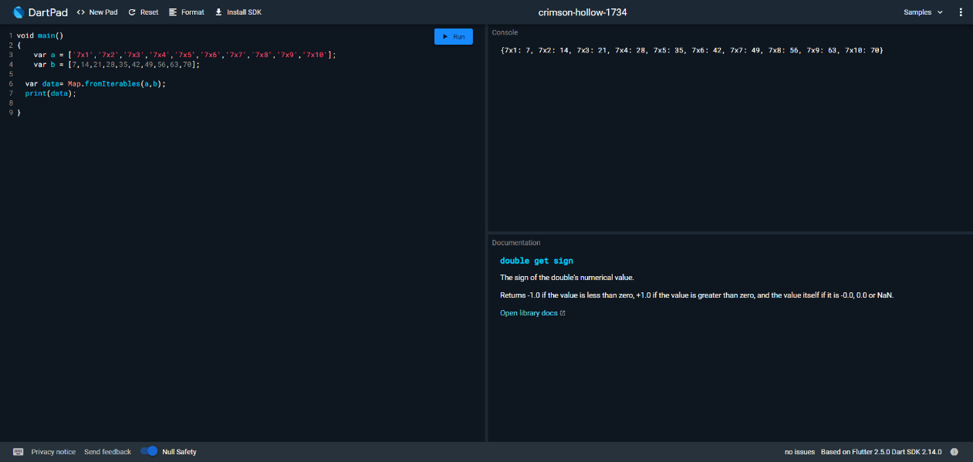

**(8) Write a program that**

**a. Store correct password in a JS variable.**

**b. Asks user to enter his/her password**

**c. Validate the two passwords:**

**d. Check if user has entered password. If not, then give message “Please**

**enter your password”**

**e. Check if both passwords are same. If they are same, show message**

**“Correct! The password you**

**f. entered matches the original password”. Show “Incorrect password”**

**otherwise.**

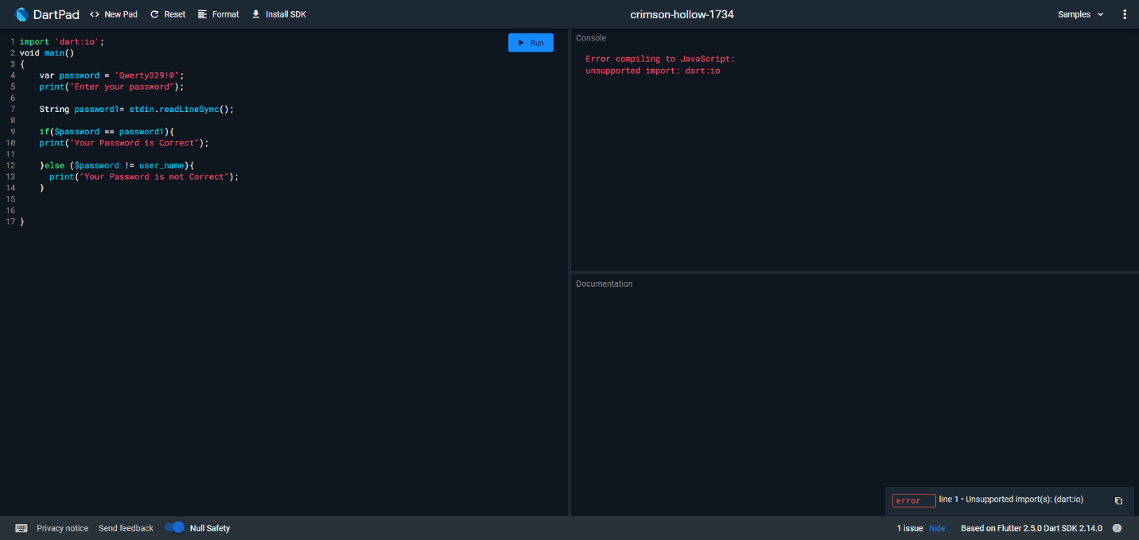

**(9) Write a program to store 3 student names in an array. Take another array to**

**store score of these three students. Assume that total marks are 500 for each**

**student, display the scores & percentages of students.**

**Write a program to replace the “Hyder” to “Islam” in the word**

**“Hyderabad” and display the result.**

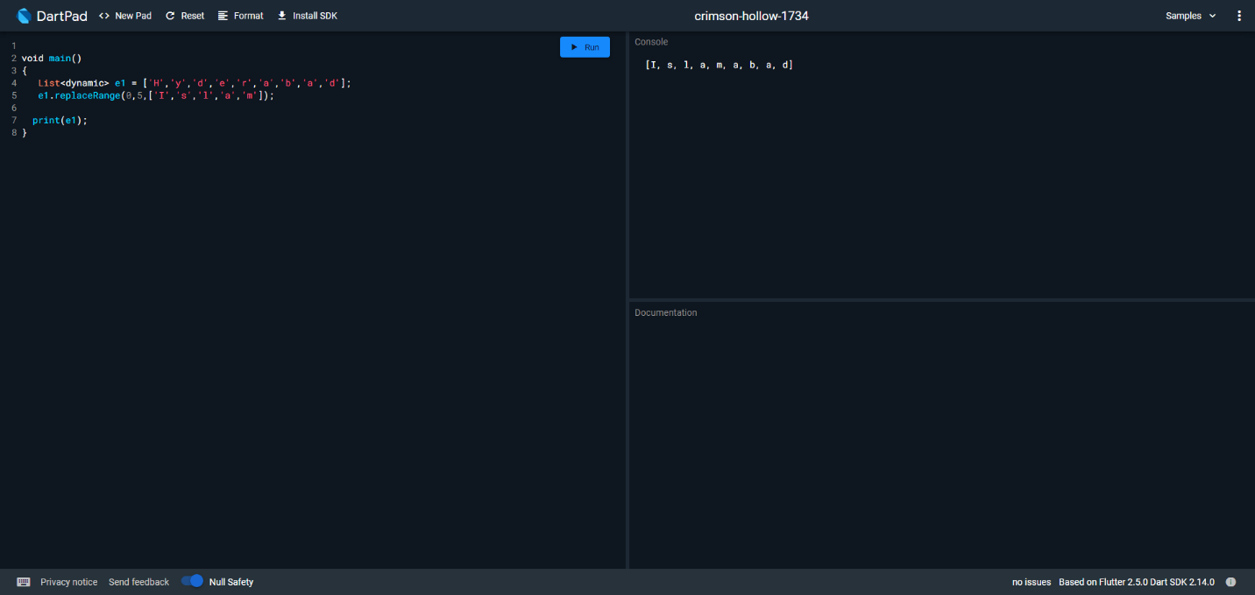

**(12) Write a program to generate your K-Electric bill 7. All the amounts should**

**be rounded off to 2 decimal places. Display the following fields:**

**a. Customer Name**

**b. Current Month**

**c. Number of units**

**d. Charges per unit**

**e. Net Amount Payable (within Due Date)**

**f. Late Payment Surcharge**

**g. Gross Amount Payable (after Due Date)**

**Where, Net Amount Payable (within Due Date) = Number of units * Charges per unit**

**& Gross Amount Payable (after Due Date) = Net Amount + Late Payment Surcharge**

